**UNEARTHING THE ENVIRONMENTAL IMPACT OF HUMAN ACTIVITY**

**A GLOBAL Co2 EMISSION ANALYSIS**



* INTRODUCTION:
* Carbon dioxide (CO2) is a colourless, odourless and non-poisonous gas formed by combustion of carbon and in the respiration of living organisms and is considered a greenhouse gas. Emissions means the release of greenhouse gases and/or their precursors into the atmosphere over a specified area and period of time. Carbon dioxide emissions or CO2 emissions are emissions stemming from the burning of fossil fuels and the manufacture of cement; they include carbon dioxide produced during consumption of solid, liquid, and gas fuels as well as gas flaring.The negative connotations of Carbon Dioxide (CO2) often lead to the misconception of it being harmful. However, a natural amount of CO2 actually plays a crucial part in maintaining our ecosystem. It only causes damage to the environment when there is an excess of CO2, usually generated by man-made activities

PROBLEM DEFINITION AND DESIGN THINKING:

EMPATHY MAP:

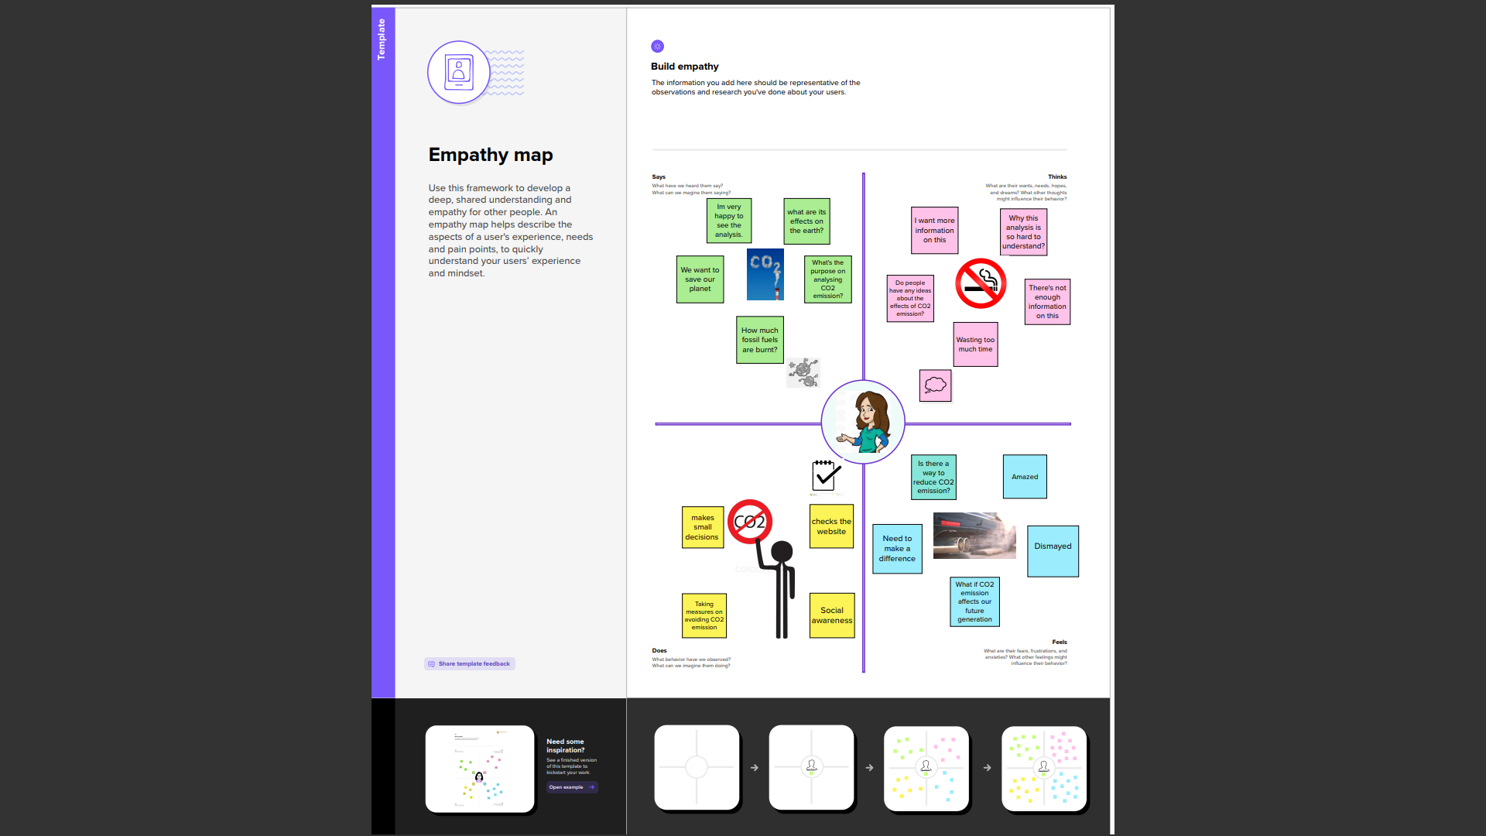

IDEATION AND BRAINSTORMING MAP:

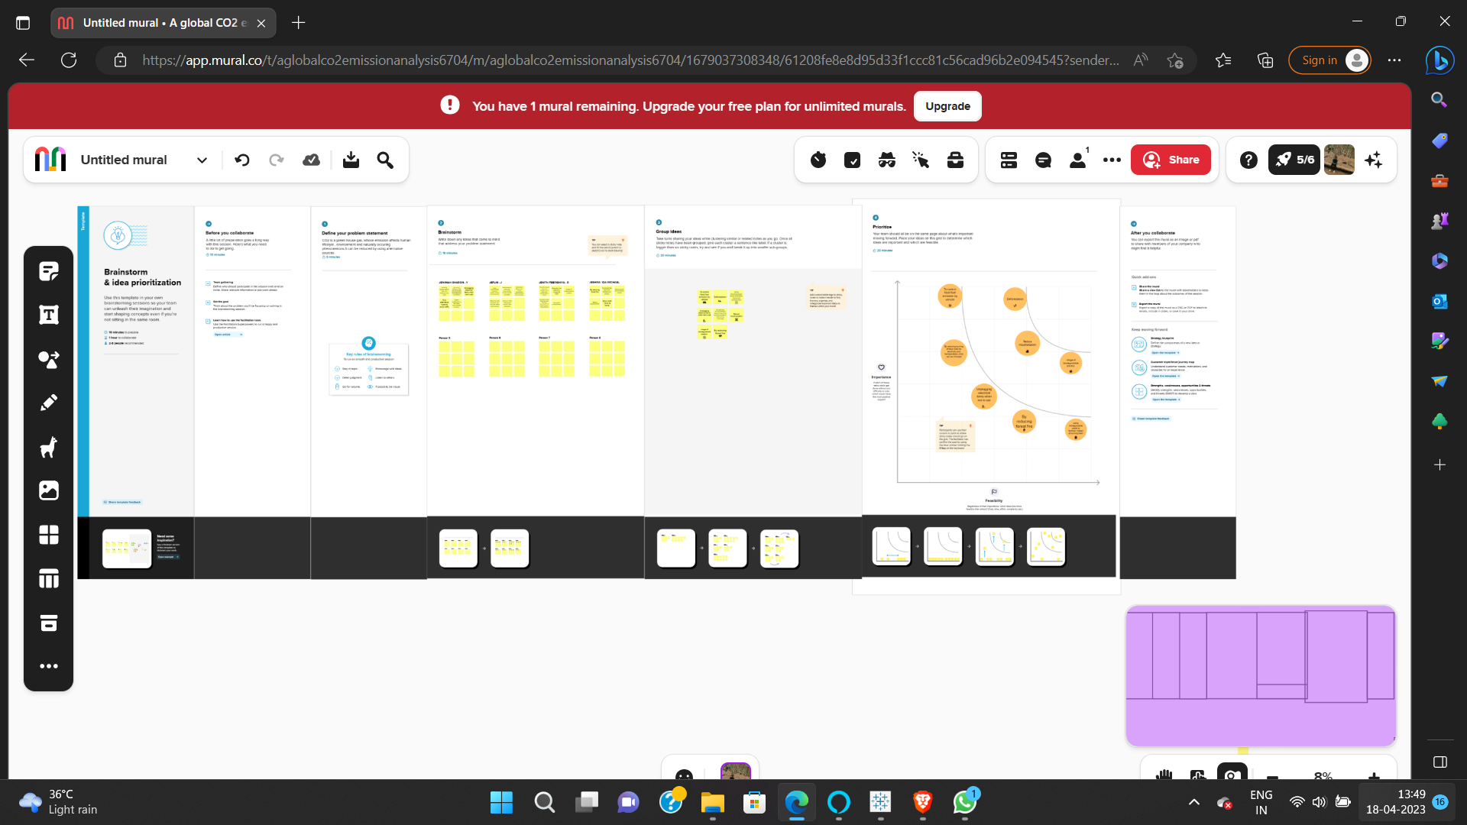

RESULT:

1.

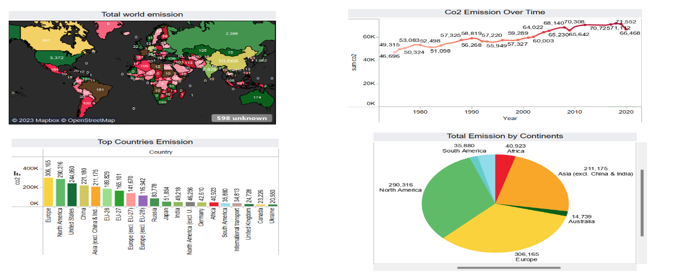

2.

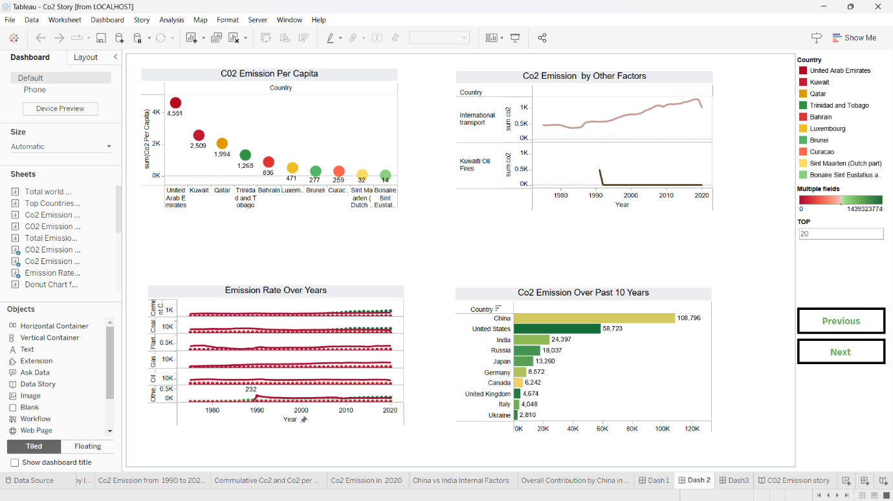

3.

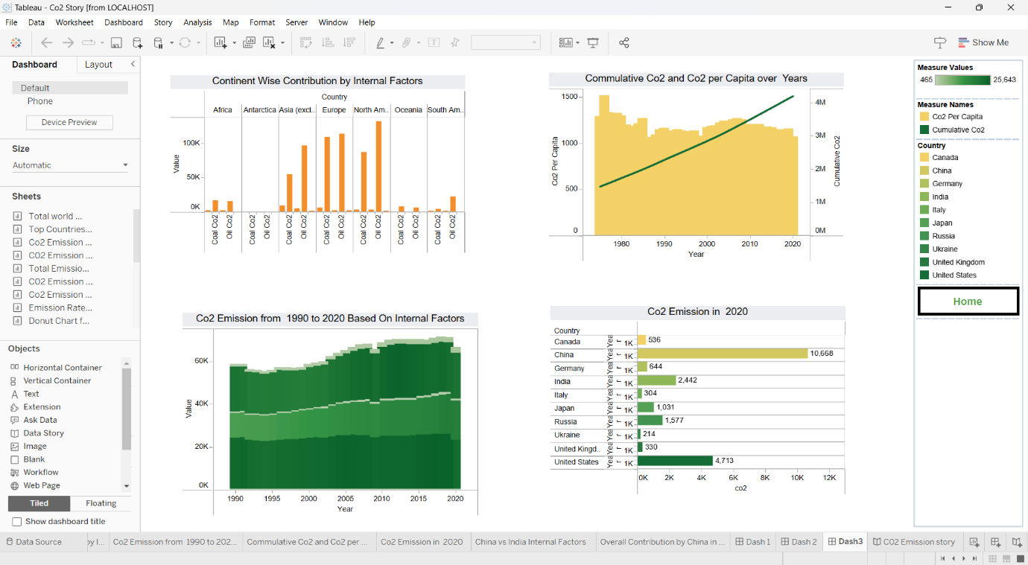

STORY:

1.

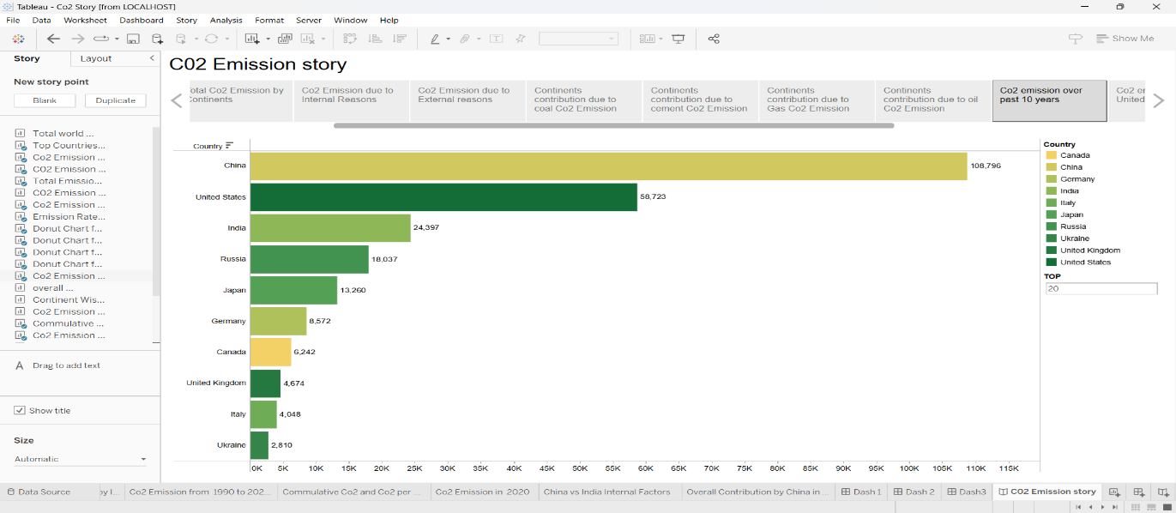

2.

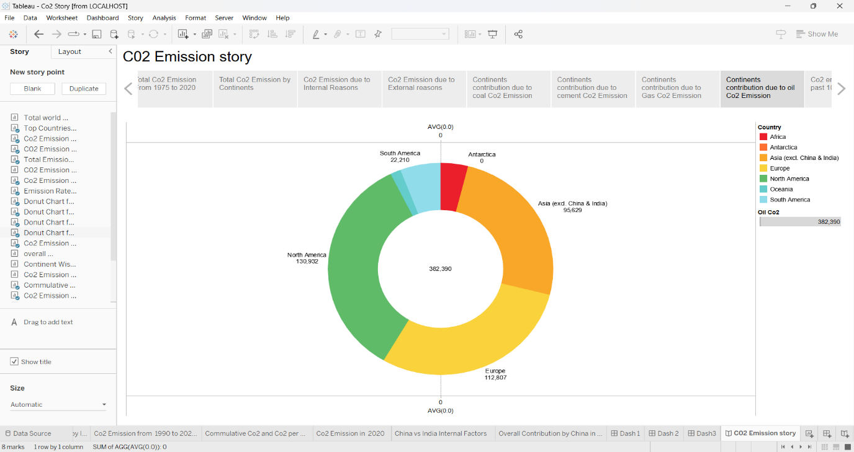

3.

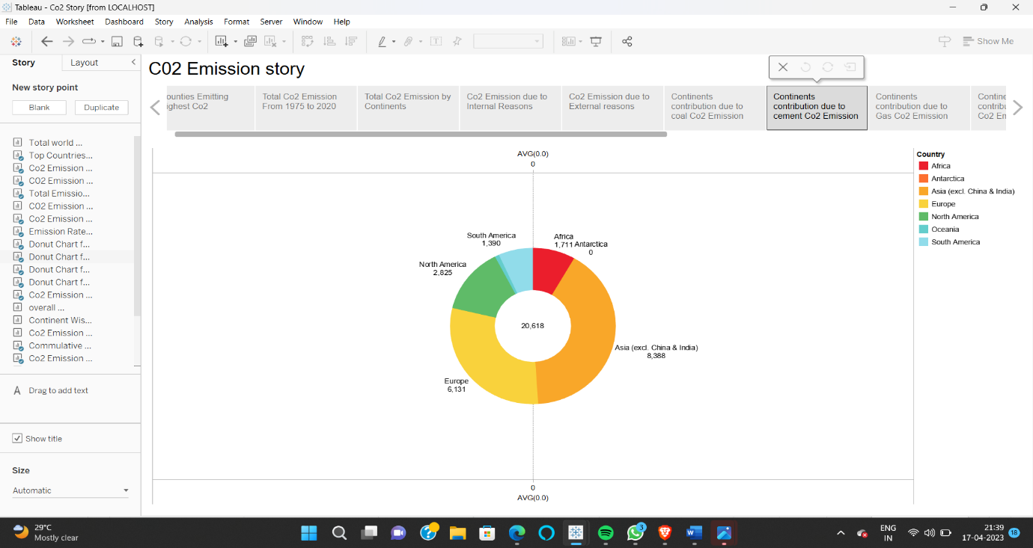

4.

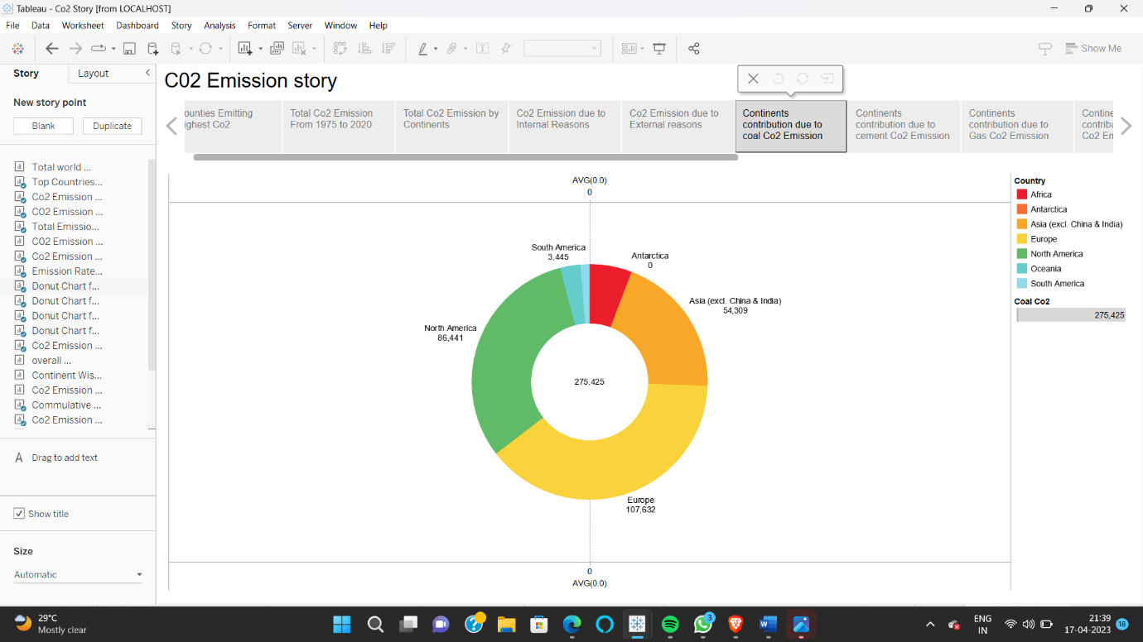

5.

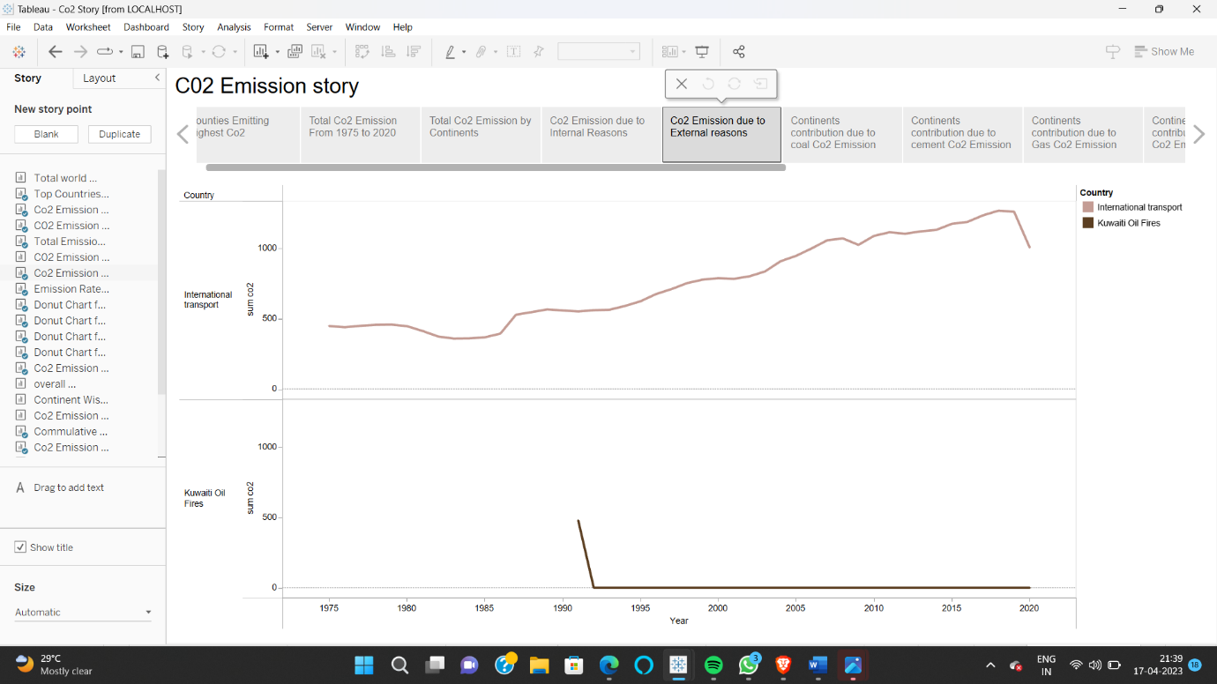

6.

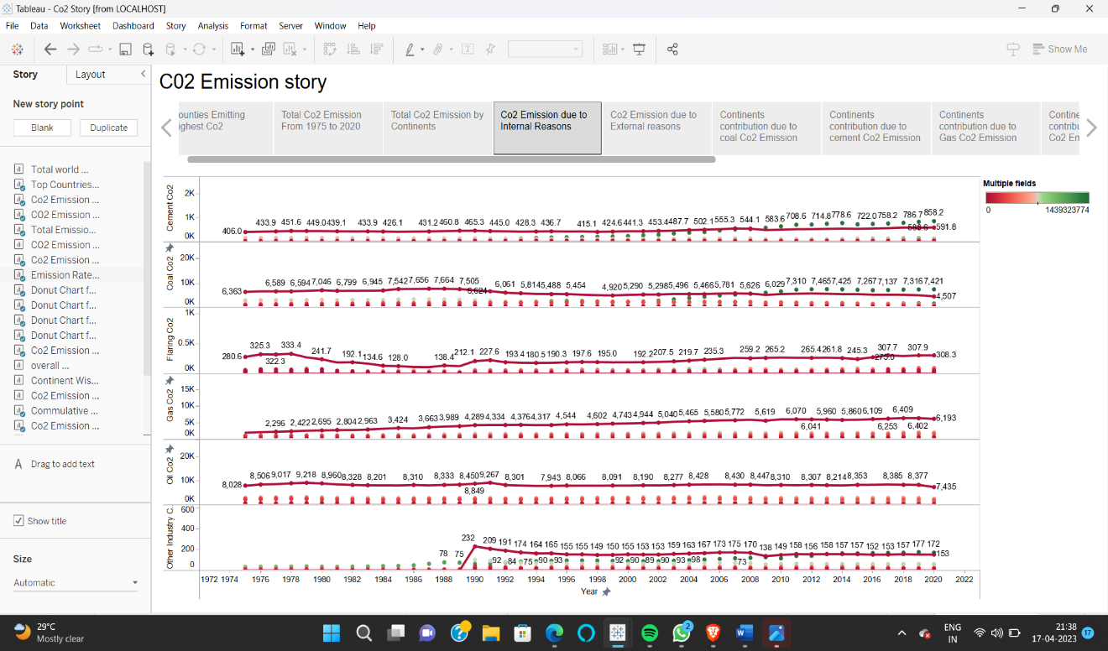

7.



8.

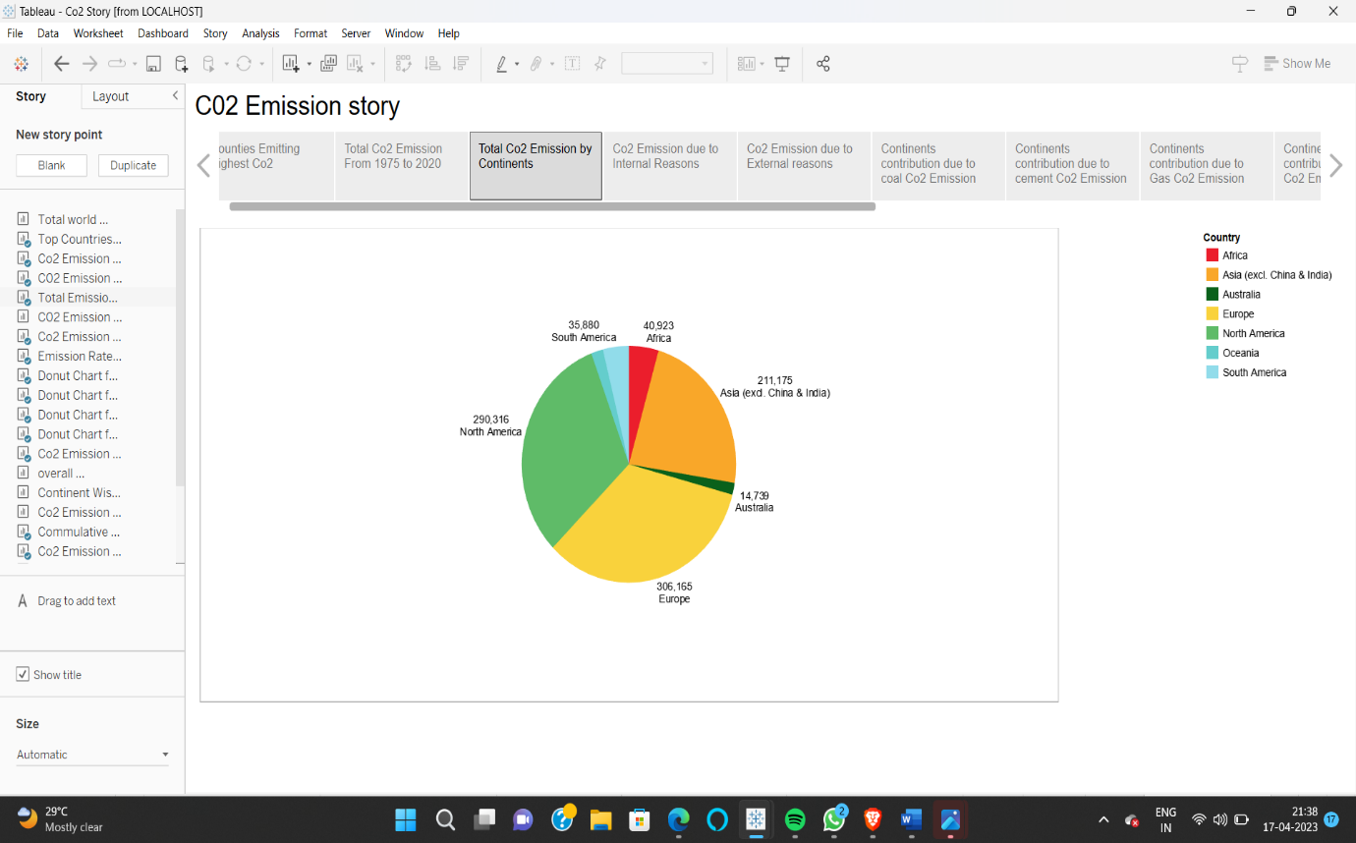

9.

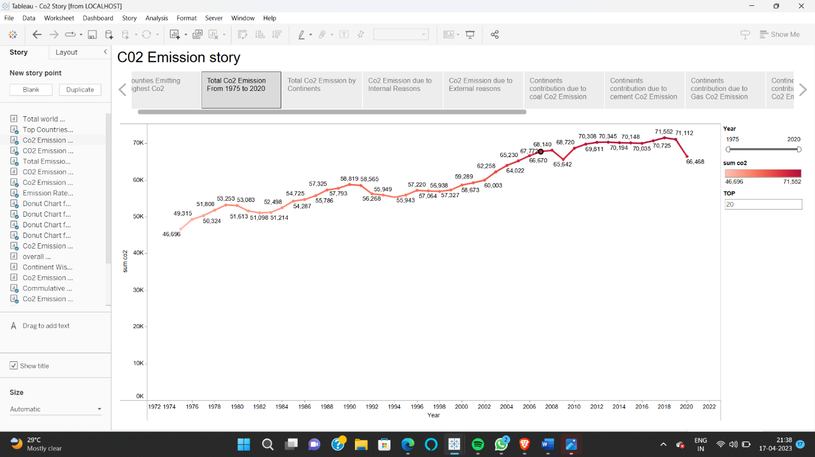

10.

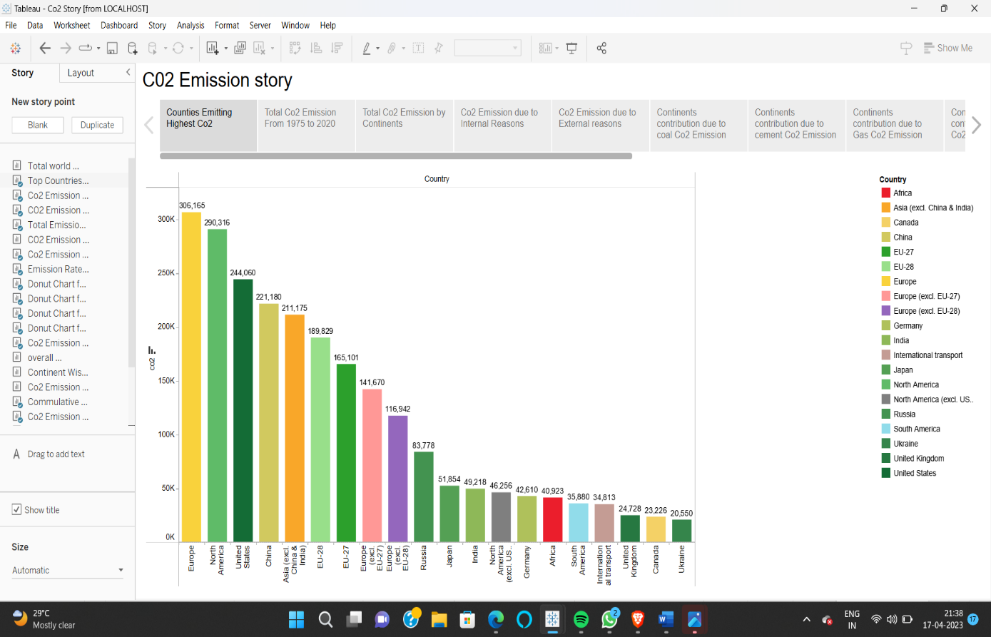

11.

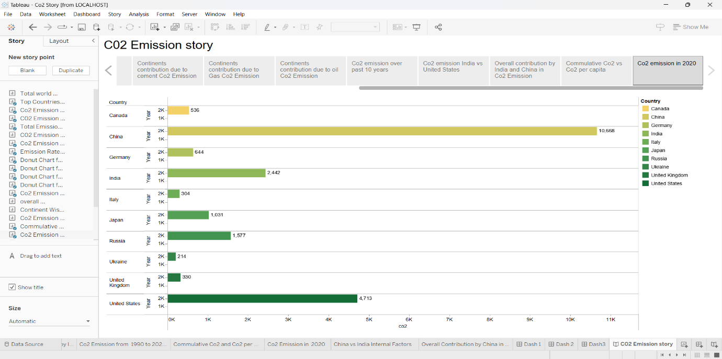

12.

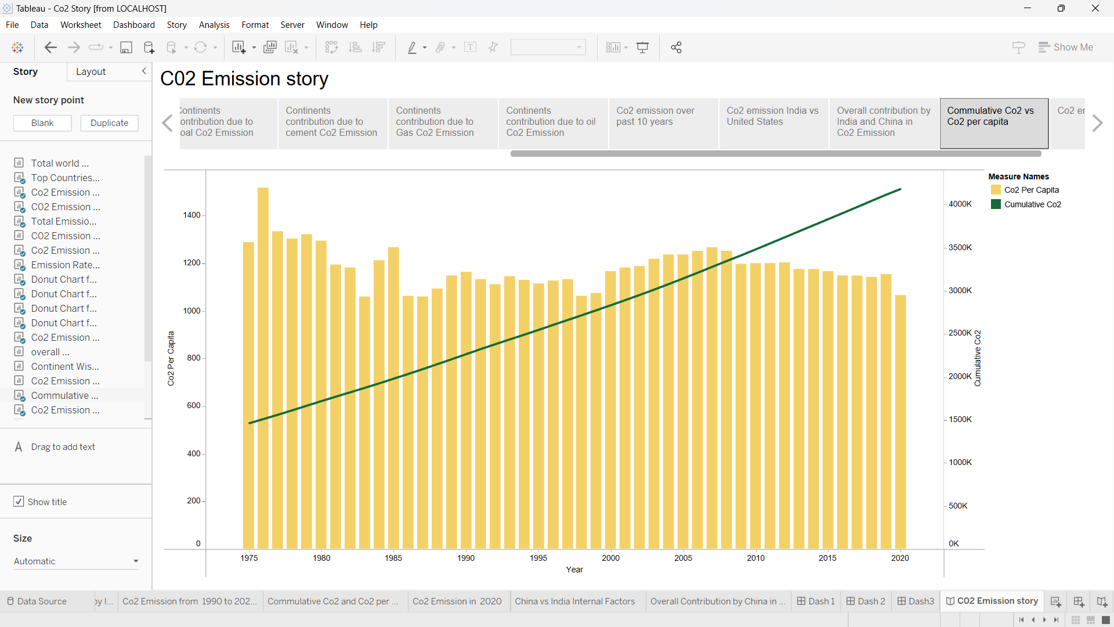

13.

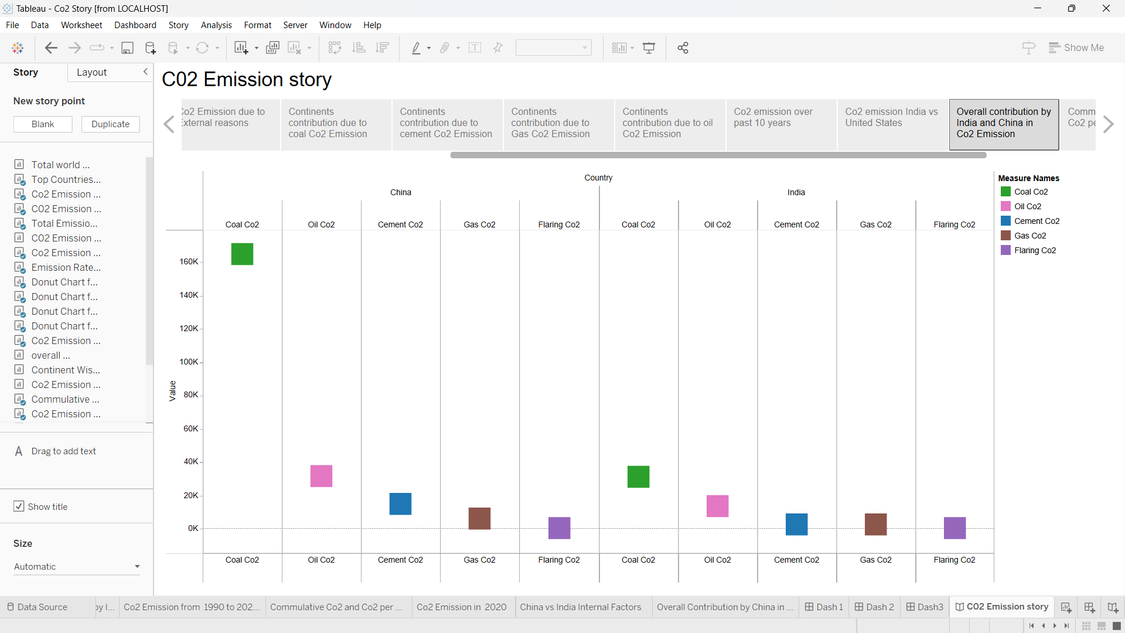

14.

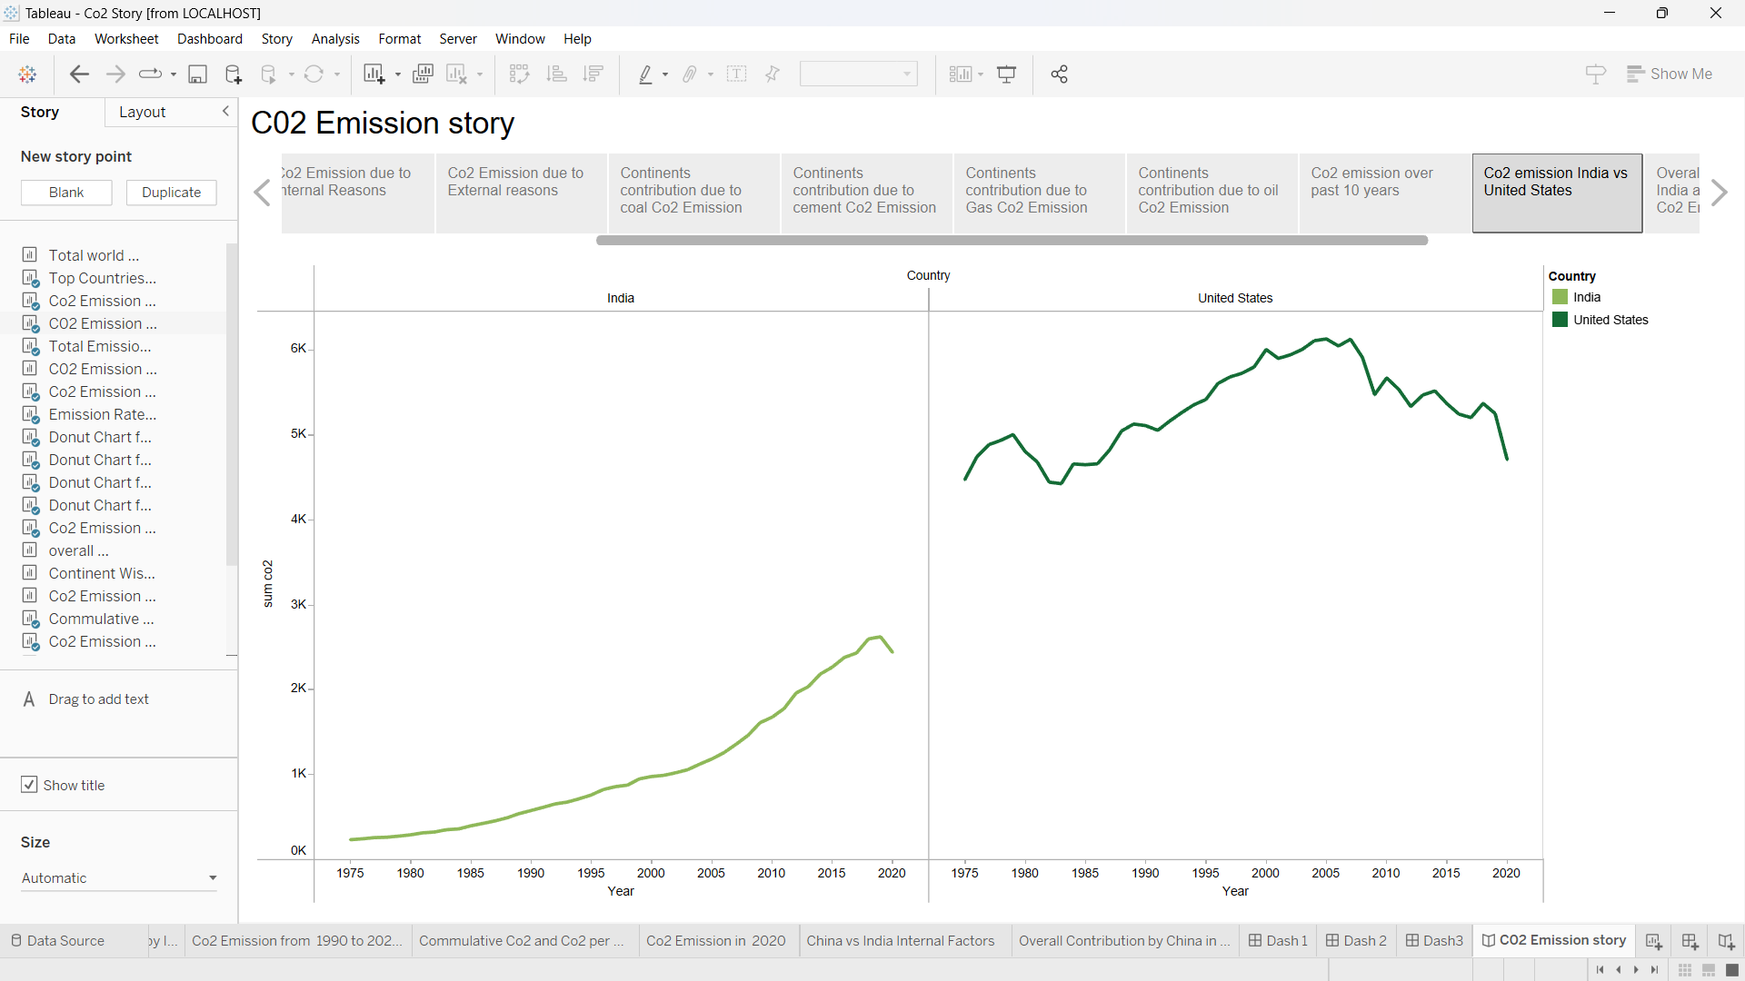

ADVANTAGES OF CO2 EMISSION ANALYSIS:

1. Less CO2 = less costs

Identifying and quantifying CO2 emissions helps to identify excessive energy usage or other inefficiencies. Lowering GHG emissions typically goes hand in hand with increasing efficiency and cost-effectiveness in a company's processes.

2. Access the carbon market

In addition to the internal cost reductions, more and more companies have to pay a price for every tonne of CO2 they emit. This is the so-called carbon emission trading system.

FUTURE SCOPE OF ANALYSING CO2 EMISSIONS:

By analysing Co2 Emissions, In future the people living on this world may take some actions and they can reduce the Co2 emissions

All direct emissions from the activities of an organization or under their control. Including on-site fuel combustion, such as gas boilers, fleet vehicles, and air-conditioning leaks.

Indirect emissions from electricity purchased and used by an organization. Emissions are created during the production of this energy, which is eventually used by the organization. This can be reduced

CONCLUSION:

The technology needs to mature further. While the individual components of CO2 capture and storage are well developed, they still need to be integrated into full scale projects in the electricity sector. Such projects would demonstrate whether the technology works when fully scaled up, thus increasing knowledge and experience. More studies are needed to analyse and reduce the costs and estimate the potential capacity of suitable geological storage sites

The adequate legal and regulatory environment also needs to be further developed. This must include agreed methods for estimating and reporting the amount of CO2 avoided by CO2 capture and storage as well as the amounts that may leak over the longer term. Long-term liabilities of geological storage and potential legal constraints on storage in the marine environment need to be taken into account.